# JavaScript Array Method Exam

**Name :**

**Batch:**

**Mode Of Exam : (online/offline)**

1 Car Booking Data

**[id , brand , model , type , pricePerDay, available]**

Let carBooking =[

        [1,’Toyota’, ‘Corolla’ , ‘Sedan’ ,50 ,10],

        [2,’Honda’, ‘Civic’ , ‘Sedan’ ,55 ,8],

        [3,’Ford’, ‘Mustang’ , ‘Sports Car’ ,80 ,5],

        [4,’Jeep’, ‘Wrangler’ , ‘SUV’ ,70 ,7],

        [5,’Nissan’, ‘Altima’ , ‘Sedan’ ,45 ,12]

];

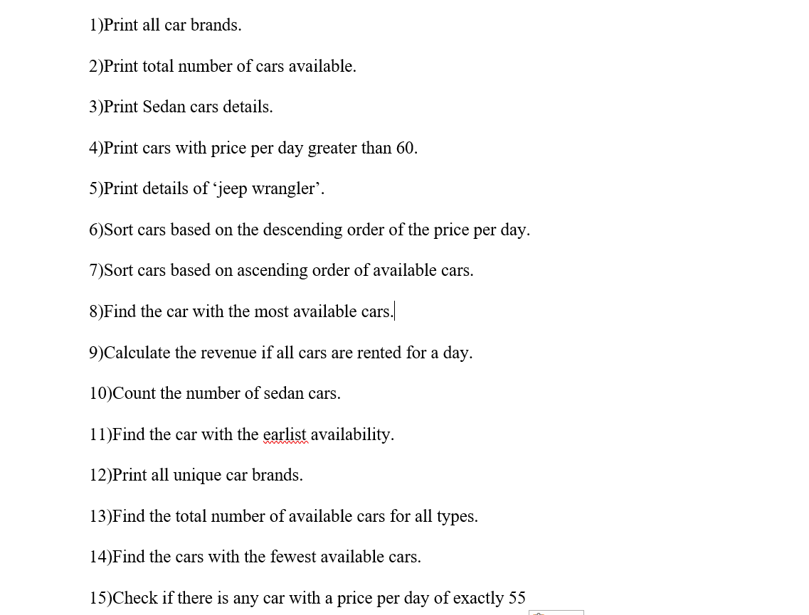

**2 Question**

const data = [ [1, 2, 3], [4, 5, 6], [7, 8, 9], [10, 11, 12] ]

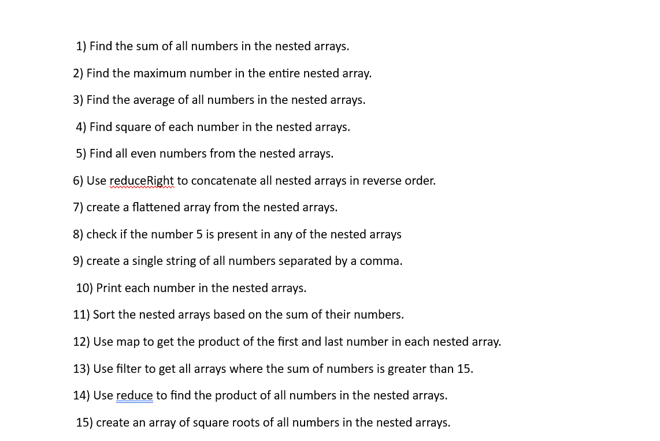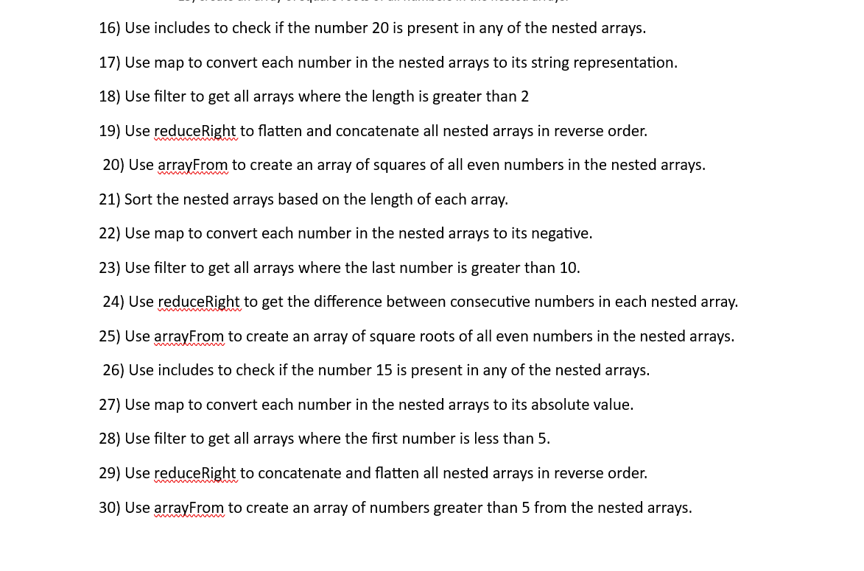

**3 Question**

const mixedData = [  
  [1, 'apple', 3, 'banana'],  
  [4, 'orange', 6, 'grape'],  
  [7, 'pear', 9, 'kiwi'],  
  [10, 'melon', 12, 'strawberry']  
];

